**Calculating Family Expenses using Service Now**

**TeamId: NM2025TMID15128**

**TeamMembers: 4**

**TeamLeader: ARSHAPRIYA A**

**TeamMember1: SWATHY A**

**TeamMember 2: KAVIYA S**

**TeamMember 3: AGALYA D**

**Problem Statement:**

Built a family expense management system in Service Now with features for categorization, budgeting, real-time tracking, and reporting to support informed financial decisions.

**Objective:**

To design and implement a family expense tracking solution in Service Now that enables efficient recording, categorization, and analysis of household expenses.

**Skills:**

**TASK INITIATION**

**Milestone1: Setting up ServiceNow Instance**

1. **Sign up for a developer account on the ServiceNow Developer site “https://developer.servicenow.com”.**
2. **Once logged in, navigate to the "Personal Developer Instance" section**
3. **Click on "Request Instance" to create a new ServiceNow instance.**
4. **Fill out the required information and submit the request.**
5. **You'll receive an email with the instance details once it's ready.**
6. **Log in to your ServiceNow instance using the provided credentials.**
7. **Now you will navigate to the ServiceNow.**

**Milestone 2: Creation of New Update Set**

1. **Creation of New Update Set**
2. **Go to All >> In the filter search for Local Update set > click on New.**
3. **Enter the Details as:**
4. **Name : Family Expenses**
5. 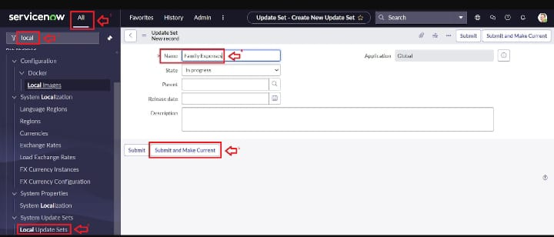**Then click on Submit and Make current.**

**Milestone 3: Creation of Table**

### Activity 1: Creation of Family Expenses Table

1. **Go to All > In the filter search for Tables > click on New.**
2. **Enter the Details:**

**Label : Family Expenses**

**Name : Auto-Populated**

**New menu name : Family Expenditure**

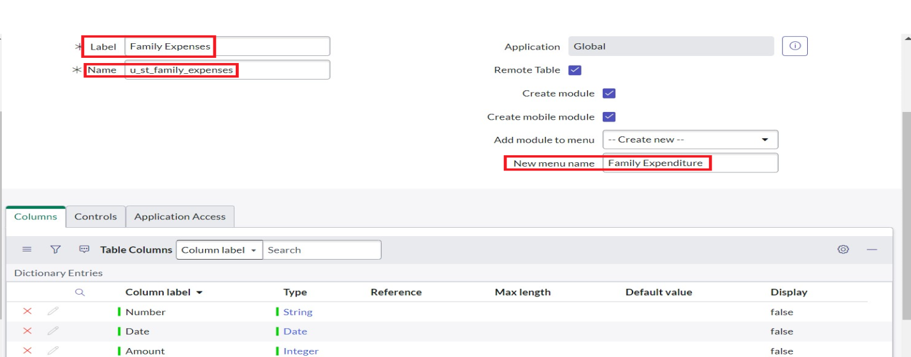

1. **Go to the Header and right click there>> click on Save.**

### Activity 2: Creation of Columns(Fields)

1. **Near Columns Double click near insert a new row.**
2. **Give the details as:**
   * 1. **Column label : Number**
     2. **Type : String**
3. **Double click on insert a new row again**
4. **Give the details as:**
   * 1. **Column label : Date**
     2. **Type : Date**
5. **Double click on insert a new row again**
6. **Give the details as:**
   * 1. **Column label : Amount**
     2. **Type : Integer**
7. **Double click on insert a new row again**
8. **Give the details as:**
   * 1. **Column label : Expense Details**
     2. **Type : String**
     3. **Max length : 800**

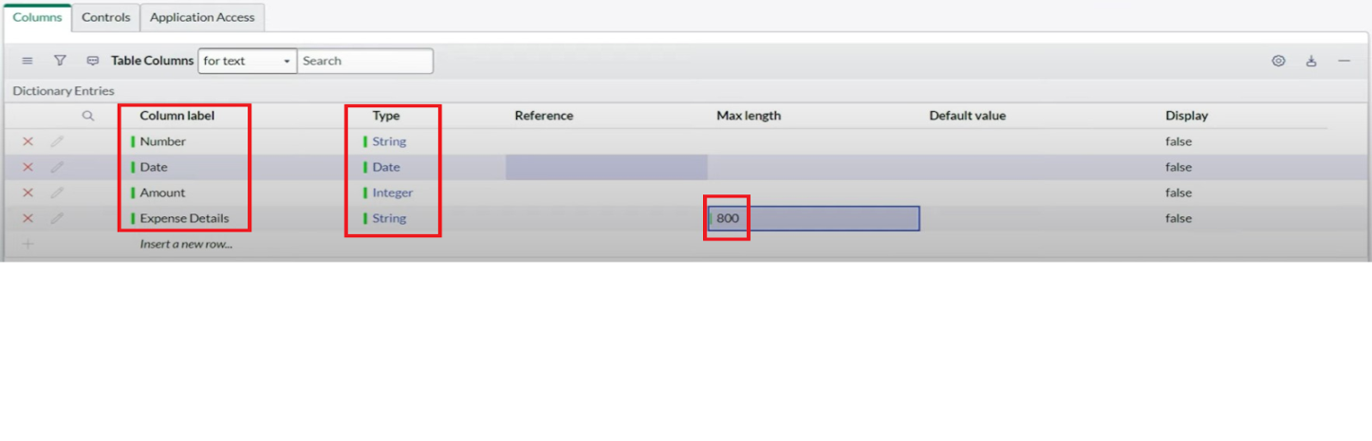

1. **Go to the Header and right click there>> click on Save.**

### Activity 3: Making Number Field an Auto-Number

1. **Double click on the Number Field/Column.**
2. **Go down and double click on Advanced view**
3. **In Default Value:**
4. **Use dynamic default : check the box**
5. **Dynamic default value : Get Next Padded Number**
6. **Click on Update.**
7. 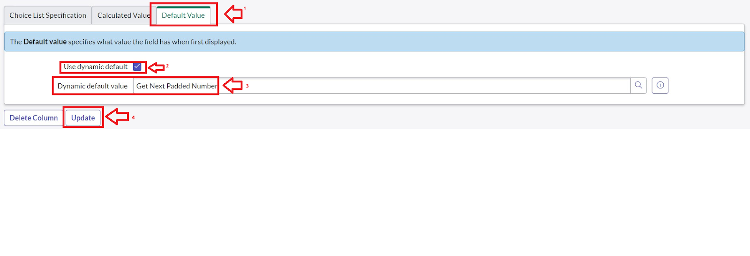
8. **Go to All >> In the filter search for Number Maintenance >> select Number Maintenance**
9. **Click on New.**
10. **Enter the below Details:**
11. **Table : Family Expenses**
12. **Prefix : MFE**

### Activity 4: Configure the Form

1. **Go to All >> In the filter search for Family Expenses >> Open Family Expenses**
2. **Click on New**
3. **Go to the Header and right click there>> click on Configure >> Select Form Design**
4. **Customize or Drag Drop the form as per your requirement.**
5. 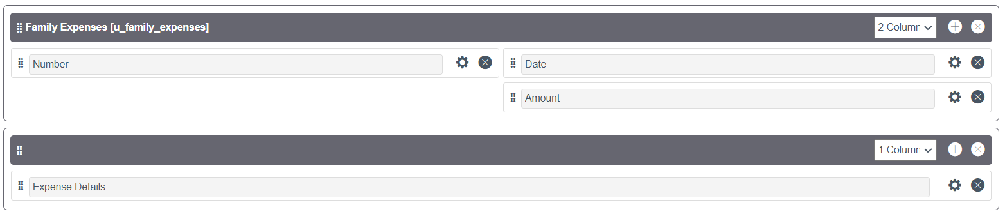
6. **Make Number Read-Only Field by clicking on the gear icon and checking Read-Only**
7. **Make Date, Amount Mandatory Field by clicking on the gear icon and checking Mandatory**
8. **Click on Save.**

# Create one more user:

1. **Create another user with the following details**
2. **Click on submit**

### Milestone 4: Creation of Table(Daily Expenses)

**1.Go to All > In the filter search for Tables > click on New.**

**2.Enter the Details:**

**3.Label : Daily Expenses**

**4.Name : Auto-Populated**

**5.Add Module to menu : Family Expenditure**

**6.Go to the Header and right click there>> click on Save.**

### Milestone 5 : Creation of Relationship

1. **Go to All >> In the filter search for Relationships >> Open Relationships**
2. **Click on New.**
3. **Enter the details:**
   1. **Name : Daily Expenses**
   2. **Applies to table : Select Family Expenses**
   3. **Daily Expenses : Select Daily Expenses**
4. **Click Save.**

### Milestone 6: Configuring Related List on Family Expenses

1. **Go to All >> In the filter search for Family Expenses >> Open Family Expenses**
2. **Click on New**
3. **Go to the Header and right click there>> click on Configure >> Select Related Lists**
4. **Add Daily Expenses to the Selected Area.**
5. **Click on Save**

### Milestone 7: Creation of Business Rules

1. **Go to All >> In the filter search for Business Rules.**
2. **Under System Definition Select Business Rules then click on New.**
3. **Enter the Details:**
   1. **Name : Family Expenses BR**
   2. **Table : Select Daily Expenses**
   3. **Check Advanced**

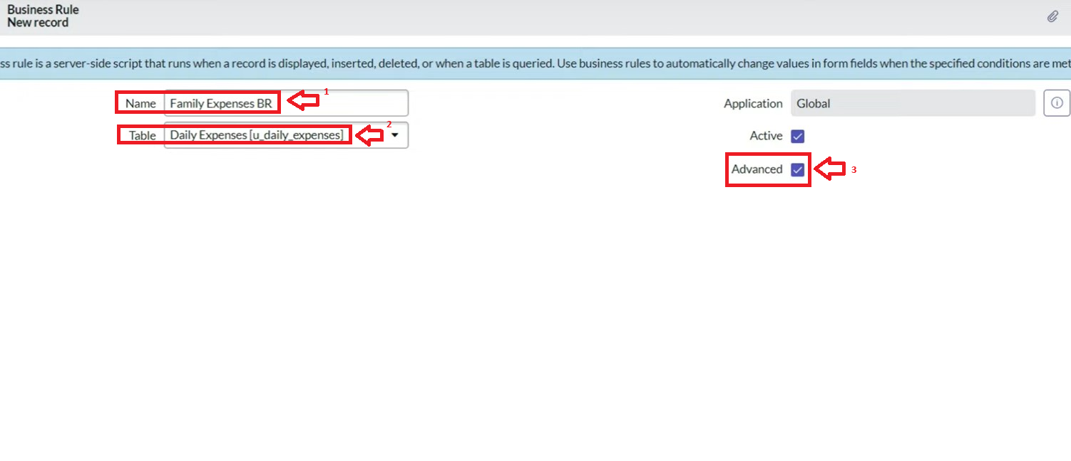

1. **In when to run Check Insert and Update**

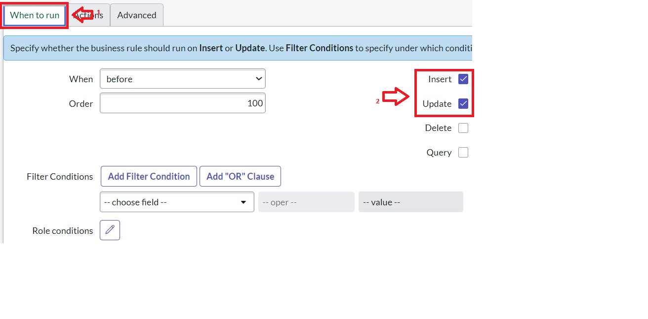

1. **In Advance(we write the code): Write the below code**

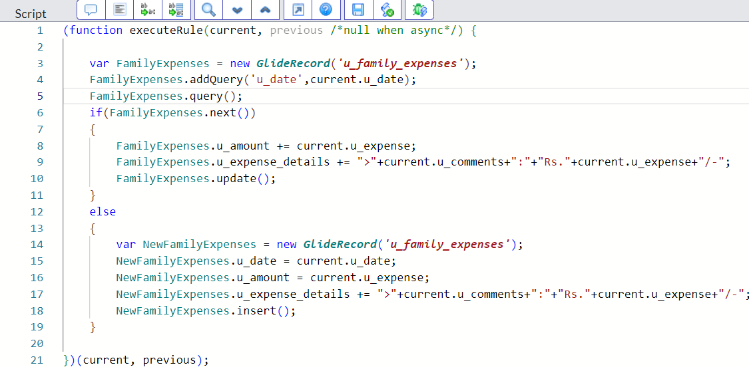

### 6.Go to the Header and right click there>> click on Save.

### Milestone 8: Configure the Relationship

1. **Go to All >> In the filter search for Relationships >> Open Relationships.**
2. **In that, open Daily Expenses Relationship.**
3. **For Applies to table : Select Family Expenses.**
4. **In Query with : write the given Query below.**
5. **Click on Update.**

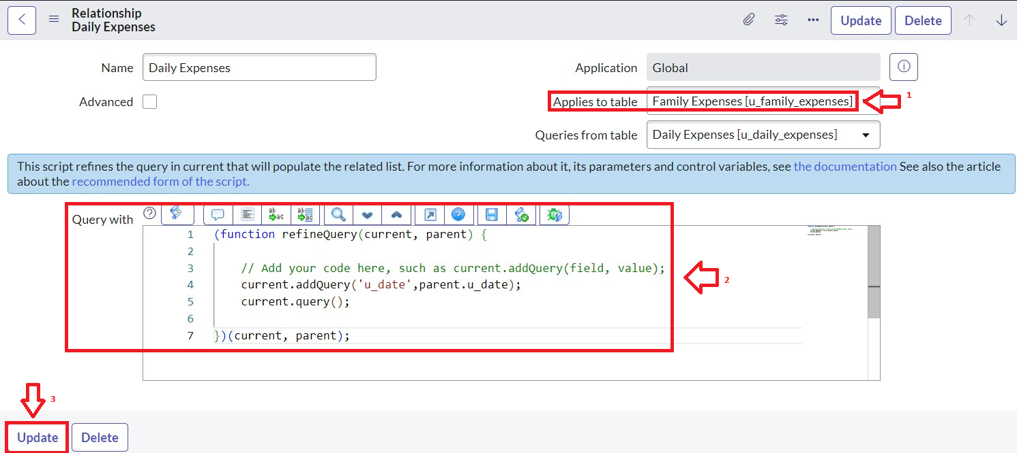

**CONCLUSION:**

The Family Expense Management System provides efficient expense categorization, budgeting, and real-time tracking, enabling better financial decision-making. It enhances transparency and supports disciplined money management for families.